JAVA
Q) What is Object?
A) An object is an entity that has attributes, behavior, and identity. Objects are members of a class
Q) What is a Class?
A) A class is a blue print of object and the attributes and behavior of an object are defined.
Q) What is Abstraction?
A) Abstraction means show only what is necessary
E.g. address book
Abstractions: name, addresses, phone numbers, etc.

Q) What is Encapsulation?
A) The process of hiding all the internal details of an object from the outside world.

Q) What is Inheritance?
A) Inheritance will allow you to define a very general class, and then later define more specialized classes.
Q) What is Polymorphism?
A) Perform the same operation on different types of classes as long as they share a common characteristic. For example, you can open a door, you can open a window, and you can open a newspaper, etc.
– Method overloading (Compile time Polymorphism)
– Method overriding (Run time polymorphism)

Q) When should I use abstract classes and when should I use interfaces?
Use Abstract Class when…
If various implementations are of same kind and share the same behavior and status we can go for the abstract class
Ex:-Abstract class as Loan and subclass are mortgage loan and car loan. In the abstract Loan class we have basic validation before to avail the loan and some abstract methods (Documents to validate) to force subclasses to provide any specific behavior.
Use Interfaces when…
- if we are creating something that provides common functionality to unrelated classes, use an interface (or) Use an interface to design a polymorphic hierarchy for value types
- Ex:-interface adds to the capability of an Object, this means I can have an Object which eats while walking, and the same Object which can dance, and also sing well. This gives polymorphic behavior (single object – multiple capabilities) to the object

Q) Can you override Static Methods in Java?

A) Well... the answer is NO if you think from the perspective of how an overriden method should behave in Java. But, you don't get any compiler error if you try to override a static method. That means, if you try to override, Java doesn't stop you doing that; but you certainly don't get the same effect as you get for non-static methods.? Because they are class methods and hence access to them is always resolved during compile time only using the compile time type information. Accessing them using object references is just an extra liberty given by the designers of Java and we should certainly not think of stopping that practice only when they restrict it :-) .Runtime Polymorphism can't be achieved by data members
Example: let's try to see what happens if we try overriding a static method:-
class SuperClass{
public static void staticMethod(){
System.out.println("SuperClass: inside staticMethod");}
}
public class SubClass extends SuperClass{
//overriding the static method
public static void staticMethod(){
System.out.println("SubClass: inside staticMethod");}
public static void main(String []args){
SuperClass superClassWithSuperCons = new SuperClass();
SuperClass superClassWithSubCons = new SubClass();
SubClass subClassWithSubCons = new SubClass();
superClassWithSuperCons.staticMethod();
superClassWithSubCons.staticMethod();
subClassWithSubCons.staticMethod();}
}
Output:-
SuperClass: inside staticMethod
SuperClass: inside staticMethod
SubClass: inside staticMethod
Q) Can interfaces contain inner classes?
Yes
public interface InterfaceInnerClass {
class example{
//Yes, you can have a inner class }}
Q) How would you prevent someone from overriding the java.lang.Object class?
A) Finally a security policy can be used to restrict which code is even allowed to change the ClassLoaders in use
Q) Super class and sub class scopes
//A is super class and B is Sub class and which child of A class
A a = new A(); //OK
A a1 = new B();//OK
B b = new B();//OK
B b1 = new A();//Compile time error
B b2 = (B)new A();//runtime error
Q) What is final modifier?
A) The final modifier keyword makes that the programmer cannot change the value anymore. The actual meaning depends on whether it is applied to a class, a variable, or a method.
- final Classes- A final class cannot have subclasses.
- final Variables- A final variable cannot be changed once it is initialized.
- final Methods- A final method cannot be overridden by subclasses.
Q) What is static block?

A) Static block which exactly executed exactly once when the class is first loaded into JVM. Before going to the main method the static block will execute.
Best practices - static variable and static method in Java
Here are some of the best practices you can follow while using static variable and method in Java.
1. Consider making a static variable final in Java to make it constant and avoid changing it from anywhere in the code. Also remember that if you change value of static final variable in Java like in enum String pattern, you need to recompile all classes which use those variable, because static final variables are cached on client side.
2) Do not use static and non static synchronized method to protect a shared resource because both method locked on different object, which means they can be executed concurrently
Q) What modifiers may be used with top-level class?
A)- public, abstract and final can be used for top-level class.

Q) Can Abstract Class have constructors? Can interfaces have constructors?
A) Abstract class's can have a constructor, but you cannot access it through the object, since you cannot instantiate abstract class. To access the constructor create a sub class and extend the abstract class which is having the constructor.
Example
public abstract class AbstractExample {
public AbstractExample(){
System.out.println("In AbstractExample()");
}
}
public class Test extends AbstractExample{
public static void main(String args[]){
Test obj=new Test();
}}
Q) What are all public methods available in Object
A)

The equals Method

The getClass Method

The toString Method

The hashCode Method

notify

notifyAll

wait (three versions)

Q: What is a test suite?
A TestSuite is group of tests. It runs a collection of test cases. This is a convenient way to group related test cases. ex.
void testSu() {
TestSuite testSuite=new TestSuite("Some test suite");
testSuite.add(test1.class);
testSuite.add(test2.class);
}
Q) Why should we write Junit test cases, as we can also test a class by creating a object instance in main method?
We can write main to test our class but this approach is not preferred because of following reasons:
•Our classes will be cluttered with test code in main method. All those test codes will be packaged into the final product.
•If we have a lots of classes to test, we will need to run the main() method of every class. This requires some extra coding effort.
•If you want the test results to be displayed in a GUI or log in HTML or text format, we will have to write code for this.
Q) How does Java allocate stack and heap memory?
A) object is created in Java it goes into the area of memory known as heap.
- The primitive variables like int and double are allocated in the stack (i.e. Last In First Out queue),
- Local variables are stored in Stack and class variables (Static varibles)are stored in heap (i.e. fields of a class).
- In Java methods and local variables are pushed into stack when a method is invoked and stack pointer is decremented when a method call is completed.
.
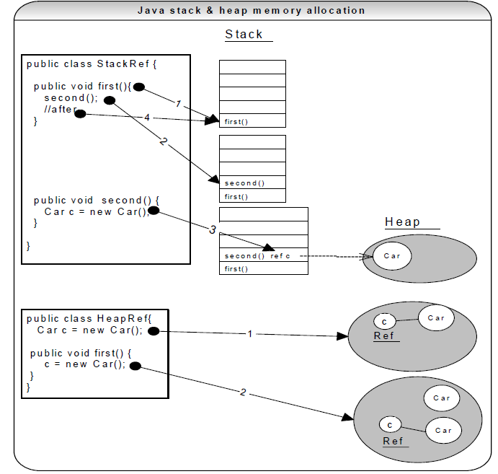
Q.) Explain static vs. dynamic class loading?
static
Classes are statically loaded with Java’s
“new” operator.
class MyClass {
public static void main(String args[]) {
Car c = new Car();
}}

dynamic

class.newInstance (); //A non-static method, which creates an instance of a
//class (i.e. creates an object).
Jeep myJeep = null ;
//myClassName should be read from a .properties file or a Constants class.
// stay away from hard coding values in your program. CO
String myClassName = "au.com.Jeep" ;
Class vehicleClass = Class.forName(myClassName) ;
myJeep = (Jeep) vehicleClass.newInstance();
myJeep.setFuelCapacity(50);

Q) Explain Java class loaders? If you have a class in a package, what do you need to do to run it? Explain dynamic class loading?

Class loaders are hierarchical. Classes are introduced into the JVM as they are referenced by name in a class that
is already running in the JVM. So, how is the very first class loaded? The very first class is especially loaded with
the help of static main( ) method declared in your class. All the subsequently loaded classes are loaded by the
classes, which are already loaded and running. A class loader creates a namespace. All JVMs include at least one
class loader that is embedded within the JVM called the primordial (or bootstrap) class loader. Now let’s look at
non-primordial class loaders. The JVM has hooks in it to allow user defined class loaders to be used in place of
primordial class loader. Let us look at the class loaders created by the JVM.
CLASS LOADER reloadable? Explanation
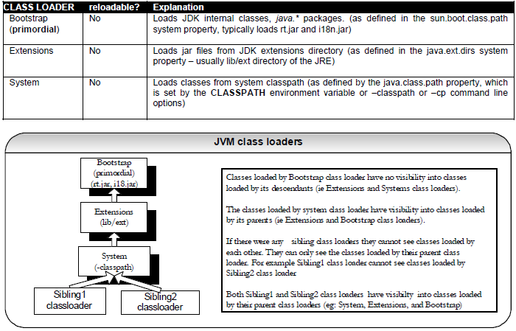

Class loaders are hierarchical and use a delegation model when loading a class. Class loaders request their
parent to load the class first before attempting to load it themselves. When a class loader loads a class, the child
class loaders in the hierarchy will never reload the class again. Hence uniqueness is maintained.

Q) Code Review Checklist in Java
Code Review Checklist in Java:
Code Review Guidelines Code reviewing is a good practice and helps in improving the code quality and
avoid un-neccessary bugs resulting from poor coding practices. When a experienced person is reviewing
the code then there are a number of check points which should be cross checked. This post lists the
points which should be used for reviewing the code hence it can act as code review cheat sheet.
The following points should be present in every code review guidelines and can act as best practices list for Java applications:
1) Javadoc comments should be added to the class as well as the methods.
2) Unused member variables should not be present in the classes.
3) Proper catch blocks should be added for exception handling instead of single Exception object handler.
4) Proper naming conventions should be used for variables, method and class names.
5) Instead of using hard coded strings, constants should be declared in a separate Constants class.
6) All database and file handlers should be properly closed when there is no further need for them.
7) No trailing spaces should be present in code lines.
8) Uniform coding standards for braces, loops, if-else, switch should be used across the application.
9) If similar logic is being used at multiple places then it should be declared in a helper class and called from multiple places.
10) A single method should not exceed 100 lines of code as it becomes difficult to maintain beyond that.
Split a single big method into multiple smaller methods.
11) Usage of API classes and methods should be encouraged instead of writing custom code for performing the same operations.
12) A single statement should not go beyond the viewable area of the editor or IDE and should be split across multiple lines.
13) Extra emphasis should be given on writing the unit test cases for the code which is going to be released.
14) The addition of any piece of code should not break existing functionality.
15) Usually a single database transaction can be done by writing the SQL query in multiple ways and there is a huge difference in the performance of database transactions depending upon the way in which SQL query is written.
16) If a class has many member variables and the instance of that class can be initialized by initializing
only a partial number of variables then it is better to have static factory methods for initializing the
member variables instead of overloading the constructors.
17) Creating immutable class should be encouraged than mutable classes.
18) The best way to check if the String object is neither null nor empty string is to use the following code: if(“”.equals(str))
19) Add appropriate access specifiers to methods instead of marking all methods in a class as public.
20) Follow best practices suggested by any framework/library being used in the application like Spring, Struts, Hibernate, jQuery.

Exception handling
Q) What is the basic difference between the 2 approaches to exception handling.
1> try catch block and
2> specifying the candidate exceptions in the throws clause?
When should you use which approach?

A) In the first approach as a programmer of the method, you self are dealing with the exception. This is fine if you are in a best position to decide should be done in case of an exception. Whereas if it is not the responsibility of the method to deal with it's own exceptions, then do not use this approach. In this case use the second approach. In the second approach we are forcing the caller of the method to catch the exceptions, that the method is likely to throw. This is often the approach library creators use. They list the exception in the throws clause and we must catch them.

Q) Explain the user defined Exceptions?
User defined Exceptions are custom Exception classes defined by the user for specific purpose. A user defined exception can be created by simply sub-classing an Exception class or a subclass of an Exception class. This allows custom exceptions to be generated (using throw clause) and caught in the same way as normal exceptions.
Example:
class CustomException extends Exception {
}
Q) What classes of exceptions may be caught by a catch clause?
A catch clause can catch any exception that may be assigned to the Throwable type. This includes the Error and Exception types. Errors are generally irrecoverable conditions
Q) What is the difference between throw and throws keywords?
The throw keyword denotes a statement that causes an exception to be initiated. It takes the Exception object to be thrown as an argument. The exception will be caught by an enclosing try-catch block or propagated further up the calling hierarchy. The throws keyword is a modifier of a method that denotes that an exception may be thrown by the method. An exception can be rethrown.
Q) What classes of exceptions are generated by the Java run-time system?
The Java runtime system generates Runtime Exceptions and Errors.
Q) What is the base class for Error and Exception?
Throwable

Q) What are Checked and Unchecked Exceptions?
A) A checked exception is subclass of Exception (or Exception itself), excluding class RuntimeException and its subclasses. Making an exception checked forces client programmers to deal with the exception may be thrown. Checked exceptions must be caught at compile time. Example: IOException.
Unchecked exceptions are RuntimeException and any of its subclasses. Class Error and its subclasses also are unchecked. With an unchecked exception, however, the compiler doesn't force client programmers either to catch the exception or declare it in a throws clause. In fact, client programmers may not even know that the exception could be thrown. Example: ArrayIndexOutOfBoundsException. Errors are often irrecoverable conditions.
Q) Does the code in finally block get executed if there is an exception and a return statement in a catch block? Or What is the purpose of the finally clause of a try-catch-finally statement?
A) The finally clause is used to provide the capability to execute code no matter whether or not an exception is thrown or caught. If an exception occurs and there is a return statement in catch block, the finally block is still executed. The finally block will not be executed when the System.exit(0) statement is executed earlier or on system shut down earlier or the memory is used up earlier before the thread goes to finally block.
try{
//some statements
}
catch{
//statements when exception is caught
}
finally{
//statements executed whether exception occurs or not
}
Q) Does the order of placing catch statements matter in the catch block?
A) Yes for compile time exceptions only, it does. The FileNoFoundException is inherited from the IOException. So FileNoFoundException is caught before IOException. Exception’s subclasses have to be caught first before the General Exception

Q) Why we need custom exceptions?
Sometimes it just helps to create custom exceptions so you can process different types of failures in different ways. For instance, if you do some custom validation and throw a custom-made ValidationException, you can keep the handling of that separate from other error handling in your catch blocks. It's just a convenience and code-clarity thing really. Because custom exceptions can be more expressive. The names of the Exceptions themselves tell a lot of the story about what went wrong.

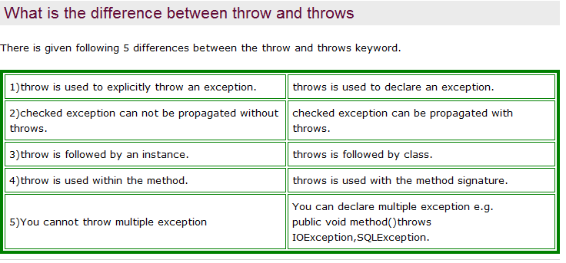
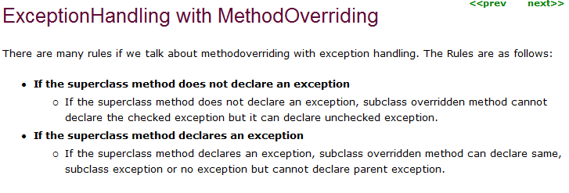

Collections

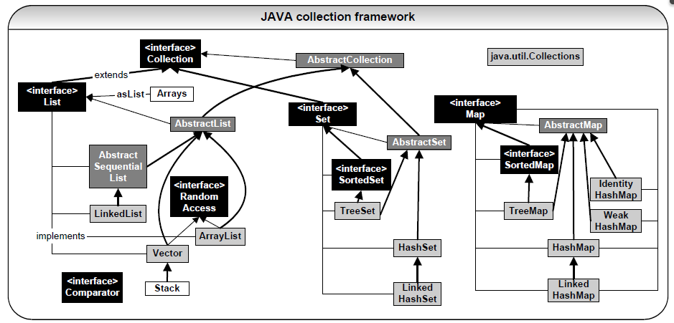

Q) Why do you get a ConcurrentModificationException when using an iterator?

Problem: The java.util Collection classes are fail-fast, which means that if one thread changes a collection while another thread is traversing it through with an iterator the iterator.hasNext() or iterator.next() call will throw ConcurrentModificationException. Even the synchronized collection wrapper classes SynchronizedMap and SynchronizedList are only conditionally thread-safe, which means all individual operations are thread-safe but compound operations where flow of control depends on the results of previous operations may be subject to threading issues.
Collection<String> myCollection = new ArrayList<String>(10);
myCollection.add("123");
myCollection.add("456");
myCollection.add("789");
for (Iterator it = myCollection.iterator(); it.hasNext();) {
String myObject = (String)it.next();
System.out.println(myObject);
if (someConditionIsTrue) {
myCollection.remove(myObject); //can throw ConcurrentModificationException in single as
//well as multi-thread access situations.
}
}
Solutions 1-3: for multi-thread access situation:
Solution 1: You can convert your list to an array with list.toArray() and iterate on the array. This approach is not recommended if the list is large.
Solution 2: You can lock the entire list while iterating by wrapping your code within a synchronized block. This approach adversely affects scalability of your application if it is highly concurrent.
Solution 3: If you are using JDK 1.5 then you can use the ConcurrentHashMap and CopyOnWriteArrayList classes, which provide much better scalability and the iterator returned by ConcurrentHashMap.iterator() will not throw
ConcurrentModificationException while preserving thread-safety.
Solution 4: for single-thread access situation:
Use:
it.remove(); // removes the current object via the Iterator “it” which has a reference to
// your underlying collection “myCollection”. Also can use solutions 1-3.
Avoid:
myCollection.remove(myObject); // avoid by-passing the Iterator. When it.next() is called, can throw the exception
// ConcurrentModificationException
Note: If you had used any Object to Relational (OR) mapping frameworks like Hibernate, you may have encountered this exception “ConcurrentModificationException” when you tried to remove an object from a collection such as a java.util Set with the intention of deleting that object from the underlying database. This exception is not caused by Hibernate but rather caused by your java.util.Iterator (i.e. due to your it.next() call). You can use one of the solutions given above.

Q) is equals () with hashcode() need to override and if not what happen and why we need to override the hashcode()

A)
In Java, every object has access to the equals() method because it is inherited from the Object class. However, this default implementation just simply compares the memory addresses of the objects. You can override the default implementation of the equals() method defined in java.lang.Object. If you override the equals(), you MUST also override hashCode(). Otherwise a violation of the general contract for Object.hashCode will occur, which can have unexpected repercussion when your class is in conjunction with all hash-based collections.
Here is the contract, copied from the java.lang.Object specialization:

public int hashCode()
Returns a hash code value for the object. This method is supported for the benefit of hashtables such as those provided by java.util.Hashtable.
The general contract of hashCode is:
- Whenever it is invoked on the same object more than once during an execution of a Java application, the hashCode method must consistently return the same integer, provided no information used in equals comparisons on the object is modified. This integer need not remain consistent from one execution of an application to another execution of the same application.
- If two objects are equal according to the equals(Object) method, then calling the hashCode method on each of the two objects must produce the same integer result.
- It is not required that if two objects are unequal according to the equals(java.lang.Object) method, then calling the hashCode method on each of the two objects must produce distinct integer results. However, the programmer should be aware that producing distinct integer results for unequal objects may improve the performance of hashtables.
Q) Why to override equals() and hashCode()? and How i can implement both equals() and hashCode() for Set ?
If you override the equals(), you MUST also override hashCode(). Otherwise a violation of the general contract for Object.hashCode will occur, which can have unexpected repercussions when your class is in conjunction with all hash-based collections.
If you are implementing HashSet to store unique object then you need to implement equals() and hashcode() method.
if two objects are equal according to the equals() method, they must have the same hashCode() value (although the reverse is not generally true).
Q) Explain about the Comparable interface
The “Comparable” allows itself to compare with another similar object (i.e. A class that implements Comparable becomes an object to be compared with). The method compareTo() is specified in the interface. Many of the standard classes in the Java library like String, Integer, Date, File etc implement the Comparable interface to give the class a "Natural Ordering". For example String class uses the following methods:

Q) Explain about Comparator interface

The Comparator is used to compare two different objects. The following method is specified in the Comparator interface.
public int compare(Object o1, Object o2)
You can have more control by writing your Comparator class. Let us write a Comparator for the Pet class shown on the below. For most cases natural ordering is fine as shown on the below, but say we require a special scenario where we need to first sort by the “petId” and then by the “petType”. We can achieve this by writing a “Comparator” class.

Q) What is a list iterator?
The java.util.ListIterator is an iterator for lists that allows the programmer to traverse the list in either direction (i.e.forward and or backward) and modify the list during iteration.
Q) What is the difference b/w Iterator and ListIterator?
Iterator : Enables you to cycle through a collection in the forward direction only, for obtaining or removing elements
ListIterator : It extends Iterator, allow bidirectional traversal of list and the modification of elements
Q) Difference between HashMap and HashTable? Can we make hashmap synchronized?
1. The HashMap class is roughly equivalent to Hashtable, except that it is unsynchronized and permits nulls. (HashMap allows null values as key and value whereas Hashtable doesn’t allow nulls).
2. HashMap does not guarantee that the order of the map will remain constant over time.
3. HashMap is non synchronized whereas Hashtable is synchronized.
4. Iterator in the HashMap is fail-safe while the enumerator for the Hashtable isn't.

Note on Some Important Terms
1) Synchronized means only one thread can modify a hash table at one point of time. Basically, it means that any thread before performing an update on a hashtable will have to acquire a lock on the object while others will wait for lock to be released.
2)Fail-safe is relevant from the context of iterators. If an iterator has been created on a collection object and some other thread tries to modify the collection object "structurally”, a concurrent modification exception will be thrown. It is possible for other threads though to invoke "set" method since it doesn’t modify the collection "structurally”. However, if prior to calling "set", the collection has been modified structurally, "IllegalArgumentException" will be thrown.
HashMap can be synchronized by
Map m = Collections.synchronizeMap(hashMap);
Q) What’s the difference between a queue and a stack?
Stack is a data structure that is based on last-in-first-out rule (LIFO), while queues are based on First-in-first-out (FIFO) rule
Q) What is difference between array & arraylist?
An ArrayList is resizable, where as, an array is not. ArrayList is a part of the Collection Framework. We can store any type of objects, and we can deal with only objects. It is growable. Array is collection of similar data items. We can have array of primitives or objects. It is of fixed size. We can have multi dimensional arrays.
Array: can store primitive ArrayList: Stores object only
Array: fix size ArrayList: resizable
Array: can have multi dimensional
Array: lang ArrayList: Collection framework
Q) How to obtain Array from an ArrayList ?
Array can be obtained from an ArrayList using toArray() method on ArrayList.
List arrayList = new ArrayList();
arrayList.add(“A”)
ObjectÂ a[] = arrayList.toArray();
//To copy an array to another array:
String[] array1 = {"a", "b", "c"};
String[] array2 = new String[2] ;
java.lang.System.arraycopy(array1,0,array2,0,2);
//convert an array to a list
List list = java.util.Arrays.asList(array2);
System.out.println(list);//prints [a, b]
//convert the list back to an array
String[] array3 = (String[])list.toArray(new String[0]);

Q) Why are Iterators returned by ArrayList called Fail Fast ?
Because, if list is structurally modified at any time after the iterator is created, in any way except through the iterator's own remove or add methods, the iterator will throw a ConcurrentModificationException. Thus, in the face of concurrent modification, the iterator fails quickly and cleanly, rather than risking arbitrary, non-deterministic behavior at an undetermined time in the future.
Q)How do you decide when to use ArrayList and When to use LinkedList?
If you need to support random access, without inserting or removing elements from any place other than the end, then ArrayList offers the optimal collection. If, however, you need to frequently add and remove elements from the middle of the list and only access the list elements sequentially, then LinkedList offers the better implementation.
Q) What are the main Implementations of the Set interface ?
The main implementations of the List interface are as follows:
- HashSet
- TreeSet
- LinkedHashSet
- EnumSet
Q) What is a HashSet ?
- A HashSet is an unsorted, unordered Set.
- It uses the hashcode of the object being inserted (so the more efficient your hashcode() implementation the better access performance you’ll get).
- Use this class when you want a collection with no duplicates and you don’t care about order when you iterate through it.
Q) What is a TreeSet ?
TreeSet is a Set implementation that keeps the elements in sorted order. The elements are sorted according to the natural order of elements or by the comparator provided at creation time.
Q) What is an EnumSet ?
An EnumSet is a specialized set for use with enum types, all of the elements in the EnumSet type that is specified, explicitly or implicitly, when the set is created.
Q) How do you decide when to use HashMap and when to use TreeMap ?
For inserting, deleting, and locating elements in a Map, the HashMap offers the best alternative. If, however, you need to traverse the keys in a sorted order, then TreeMap is your better alternative. Depending upon the size of your collection, it may be faster to add elements to a HashMap, then convert the map to a TreeMap for sorted key traversal.
Q) What is a TreeMap ?
TreeMap actually implements the SortedMap interface which extends the Map interface. In a TreeMap the data will be sorted in ascending order of keys according to the natural order for the key's class, or by the comparator provided at creation time. TreeMap is based on the Red-Black tree data structure.

Q) What Are the different Collection Views That Maps Provide?
Maps Provide Three Collection Views.
- Key Set - allow a map's contents to be viewed as a set of keys.
- Values Collection - allow a map's contents to be viewed as a set of values.
- Entry Set - allow a map's contents to be viewed as a set of key-value mappings.
Q) What is an EntrySet View ?
Entry Set view is a set that is returned by the entrySet() method in the map and contains Objects of type Map. Entry each of which has both Key and Value
Map<String, String> map = new Hashmap< String, String>();
for(Entry< String, String> entry : map.entrySet()){
String key = entry. getKey();
String value = entry. getValue();
}
SET:
- HashSet is an implementation for Set Interface

- If you add any duplicate value, HashSet will override with latest value. So it never allows the duplicate.
- Null values can be added as normal values, but it will override the latest null value ,so only one null value can allowed.
- HashSet is unsorted class.
- HashSet is unsynchronized , so multiple threads can access the HashSet.
- SortedSet is a interface which extends the Set.
- TreeSet is an implementation for SortedSet Interface.
- If you add any duplicate value, HashSet will override with latest value. So it never allows the duplicate.
- Null values cannot be added in the TreeSet, if we add it throw Null pointer exception at a runtime.
- TreeSet is give the values in sorted order
- TreeSet is unsynchronized , so multiple threads can access the TreeSet.
- Need to implements the comparable interface in added Class Object.

List:
- ArrayList is an implementation for List Interface

- ArrayList allows the duplicate.
- Null values can be added in the ArrayList.
- ArrayList is a sorted by using Collections.sort(LIST); utility class.
- ArrayList is unsynchronized , so multiple threads can access the ArrayList
- ArrayList is slow in Insertion because the no Overhead in the Array List as it follows Array in adding the elements.Array has 3 elements as [0-B], [1-C], [2-D] now if we add a new element “A ” in Array it will shift all the index values to right side to store the new values as [0-A], [1-B], [2-C], [3-D]. I,e all the elements shifting cause the time consuming.
ArrayList internally uses and array to store the elements, when that array gets filled by inserting elements a new array of roughly 1.5 times the size of the original array is created and all the data of old array is copied to new array. During deletion, all elements present in the array after the deleted elements have to be moved one step back to fill the space created by deletion.
- LinkedList is ian implementation for List Interface.
- LinkedList allows the duplicate.
- Null values can be added in the LinkedList.
- LinkedList is a sorted by using Collections.sort(LIST); utility class.
- LinkedList is unsynchronized , so multiple threads can access the ArrayList
- LinkedList is fast in Insertion because Overhead in the Array List as it follows Array in adding the elements.In linked list data is stored in nodes that have reference to the previous node and the next node so adding element is simple as creating the node an updating the next pointer on the last node and the previous pointer on the new node. Deletion in linked list is fast because it involves only updating the next pointer in the node before the deleted node and updating the previous pointer in the node after the deleted node.
Map
1) HashMap is an implementation for Map Interface

a) If you add any duplicate value for key in HashMap it will override with latest value. So it never allows the duplicate.
b) Multiple Null values can be added for key and values in the HashMap, but it will override with latest value based on key.
c) If your HashSet will only be accessed from multipule threads, we can use a HashSet because HashSet is unsynchronized.
d) HashMap will give the values in unsorted order
HashMap values can be retrievd in efficient way as shown below

HashMap <Integer, String> hm = new HashMap HashMap <Integer, String>();
hm.put(1, “name”);
hm.put(2,”age”);
for(Map.Entry<Integer, String> entry: hm.entrySet()){
System.out.println(hm.get(entry.getKey()));
}

2) HashTable is an implementation for Map Interface

a) If you add any duplicate valuefor key , HashTable will override with latest value. So it never allows the duplicate.
b) Null values cannot be added for key and values in the HashTable
c) If your HashTable will be accessed from single threads, use a HashTable because HashTable is synchronous.
d) HashTable will give the values in unsorted order.

HashTable values can be retrievd in efficient way as shown below
HashTable <Integer, String> hm = new HashTable <Integer, String>();
hm.put(1, “name”);
hm.put(2,”age”);
for(Map.Entry<Integer, String> entry: hm.entrySet()){
System.out.println(hm.get(entry.getKey()));
}
3) SortedMap is a interface which extends the Set.
- TreeMap is an implementation for SortedSet Interface.
I. If you add any duplicate value, HashSet will override with latest value. So it never allows the duplicate.
II. Null values cannot be added in the keys of TreeMap, it throws a runtime Null pointer exception, but it accept null for values.
III. TreeMap will give the keys (respective values) in sorted order.
IV. If your TreeMap will only be accessed from a single thread, we can use a TreeMap because TreeMap is unsynchronized.
- Need to implements the comparable interface in added Class Object.

TreeMap values can be retrievd in efficient way as shown below

Map <Integer, String> hm = new TreeMap <Integer, String>();
hm.put(1, “name”);
hm.put(2,”age”);
for(Map.Entry<Integer, String> entry: hm.entrySet()){
System.out.println(hm.get(entry.getKey()));
}

Q) How HasMap will main the key and values in java
A>> HashMap works on principle of hashing, we have put () and get () method for storing and retrieving object form hashMap.When we pass an both key and value to put() method to store on HashMap, it uses key object hashcode() method to calculate hashcode and they by applying hashing on that hashcode it identifies bucket location for storing value object.While retrieving it uses key object equals method to find out correct key value pair and return value object associated with that key. HashMap uses linked list in case of collision and object will be stored in next node of linked list.Also hashMap stores both key+value tuple in every node of linked list.
Q) Java concurrency: Understanding CopyOnWriteArrayList and CopyOnWriteArraySet
Java has a huge amount of useful collections and several are made specifically for use in concurrent code like the ConcurrentHashMap.
Two sometimes very useful classes are the CopyOnWriteArrayList and CopyOnWriteArraySet. They implement the java.util.List and the java.util.Set interface respectively.
Let’s focus on the CopyOnWriteArrayList to understand what it is all about. Contrary to the ArrayList, this class is thread safe. This means when you use it from several threads no undefined state can occur in the list.
As will all data structures it is important to understand when to use them. As the name CopyOnWrite says, a copy of the whole list is made each time you write to the list like adding an element or remove an element. As you can figure out yourself, this can be pretty expensive when your list is large.
This means that a CopyOnWriteArrayList (and CopyOnWriteArraySet) is mostly useful when you have few modifications but many reads because reads are very cheap and don’t require synchronization.
When you iterate over a CopyOnWriteArrayList and CopyOnWriteArraySet the iterator uses a snapshot of the underlying list (or set) and does not reflect any changes to the list or set after the snapshot was created. The iterator will never throw a ConcurrentModificationException.
Here is a code example:
1  2  3  4  5  6  7  8  9  10  11  12  13  14  15  16  17  18  19  20  21  22  23  24  25  26  27  28  29  30  31  32 | import java.util.Arrays;  import java.util.concurrent.CopyOnWriteArrayList;  public class CopyOnWriteTest {  public static void main(String[] args) throws InterruptedException {  final CopyOnWriteArrayList<Integer> numbers = new CopyOnWriteArrayList<>(  Arrays.asList(1, 2, 3, 4, 5));  // new thread to concurrently modify the list  new Thread(new Runnable() {  @Override  public void run() {  try {  // sleep a little so that for loop below can print part of  // the list  Thread.sleep(250);  } catch (InterruptedException e) {  Thread.currentThread().interrupt();  }  numbers.add(10);  System.out.println("numbers:" + numbers);  }  }).start();  for (int i : numbers) {  System.out.println(i);  // sleep a little to let other thread finish adding an element  // before iteration is complete  Thread.sleep(100);  }  }  }
Here is the output of this code:
numbers:[1, 2, 3, 4, 5, 10]
As you can see the for loop only prints the numbers 1-5 and the number 10 is not printed in the for loop as it was not present when the snapshot of the iterator was taken.
Conclusion:
CopyOnWriteArrayList and CopyOnWriteArraySet (which is implemented with a CopyOnWriteArrayList) are special data structures for use cases where you want to share the data structure among several threads and have few writes and many reads.
Always make sure to do a performance test for your code on real hardware to see how it performs in your application. And make sure to read the javadoc for all the methods to really understand how the data structures work.Of course you can also use CopyOnWriteArrayList and CopyOnWriteArraySet from other JVM languages like Scala, Clojure, JRuby or Groovy.
Q) How to make Collection ready only or what is Immutable collections.
Sometimes you just need to create the list or set once and then later only read from it. In this case I recommend having a look at the immutable collections from Guava.. They are always thread safe (as is every really immutable object) and are a better alternative to the wrapped immutable collections that come with the JDK. See the Guava website for why that is the case.
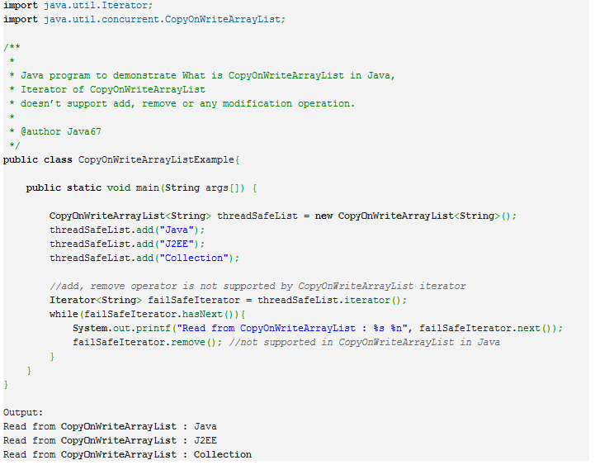

Q) What is the ConcurrentHashMap in Java?
The point is to provide an implementation of HashMap that is threadsafe. Multiple threads can read from and write to it without the chance of receiving out-of-date or corrupted data. ConcurrentHashMap provides its own synchronization, so you do not have to synchronize accesses to it explicitly.
Another feature of ConcurrentHashMap is that it provides the putIfAbsent method, which will atomically add a mapping if the specified key does not exist. Consider the following code:
ConcurrentHashMap<String, Integer> myMap = new ConcurrentHashMap<String, Integer>();

// some stuff

if (!myMap.contains("key")) {
myMap.put("key", 3);
}
This code is not threadsafe, because another thread could add a mapping for "key" between the call to contains and the call to put. The correct implementation would be:
myMap.putIfAbsent("key", 3);
Iteration over a ConcurrentHashMap are a little different from those offered by other collections. The iterators are not fail-fast in the sense that they do not throw a ConcurrentModificationException. They also do not guarantee that once the iterator is created it will list/show all elements that are added after its creation. The iterators do however guarantee that any updates or removal of items will be reflected correctly in their behaviour. They also guarantee that no element will be returned more than once while traversal.
When you iterate on the entries of a ConcurrentHashMap, "the iterator is a "weakly consistent" iterator that will never throw ConcurrentModificationException, and guarantees to traverse elements as they existed upon construction of the iterator, and may (but is not guaranteed to) reflect any modifications subsequent to construction." That's probably the best you can get
Retrieval operations (including get) generally do not block, so may overlap with update operations (including put and remove). Retrievals reflect the results of the most recently completed update operations holding upon their onset. For aggregate operations such as putAll and clear, concurrent retrievals may reflect insertion or removal of only some entries. Similarly, Iterators and Enumerations return elements reflecting the state of the hash table at some point at or since the creation of the iterator/enumeration.

Q) Write a program to implement ArrayList
import java.util.Arrays;

public class MyArrayList {

private Object[] myStore;
private int actSize = 0;

public MyArrayList(){
myStore = new Object[10];
}

public Object get(int index){
if(index < actSize){
return myStore[index];
} else {
throw new ArrayIndexOutOfBoundsException();
}
}

public void add(Object obj){
if(myStore.length-actSize <= 5){
increaseListSize();
}
myStore[actSize++] = obj;
}

public Object remove(int index){
if(index < actSize){
Object obj = myStore[index];
myStore[index] = null;
int tmp = index;
while(tmp < actSize){
myStore[tmp] = myStore[tmp+1];
myStore[tmp+1] = null;
tmp++;
}
actSize--;
return obj;
} else {
throw new ArrayIndexOutOfBoundsException();
}

}

public int size(){
return actSize;
}

private void increaseListSize(){
myStore = Arrays.copyOf(myStore, myStore.length*2);
System.out.println("\nNew length: "+myStore.length);
}

public static void main(String a[]){
MyArrayList mal = new MyArrayList();
mal.add(new Integer(2));
mal.add(new Integer(5));
mal.add(new Integer(1));
mal.add(new Integer(23));
mal.add(new Integer(14));
for(int i=0;i<mal.size();i++){
System.out.print(mal.get(i)+" ");
}
mal.add(new Integer(29));
System.out.println("Element at Index 5:"+mal.get(5));
System.out.println("List size: "+mal.size());
System.out.println("Removing element at index 2: "+mal.remove(2));
for(int i=0;i<mal.size();i++){
System.out.print(mal.get(i)+" ");
}
}
}

Threads

Life Cycle Methods in Threads
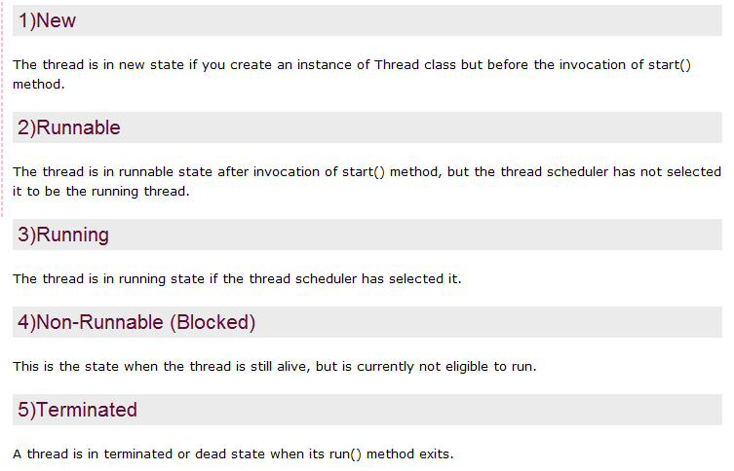
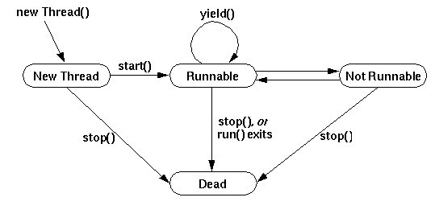

how_multithreading_works

Typical java web applications are multi-threaded in that every request is handled on its own thread. In such applications, you have to be careful when you have objects that maintain state (via modifying a static property, for example), as they can overwrite each other. Each thread will still have their own stack, which means, each thread will have a different copy of local variables to work on. As a result there will be no interference between threads and you won't have to worry about concurrent calls. Only when a shared resource, e.g. instance/class variable is accessed, there can be a problem. Same thing if instance/class variable is directly accessed concurrently. When you are talking about servlets, if two requests come in at the same time to the same servlet, the relevant servlet code is being executed twice concurrently. In frameworks like Struts or Spring, which delegate requests to objects, either the same bean instance can be reused, or a new bean instance could be created for each request, depending on how you have your framework configured (i.e. to use prototypes or singletons in the case of Spring).Any implementation of the Controller interface should be a reusable, thread-safe class, capable of handling multiple HTTP requests throughout the lifecycle of an application
Q) Apart from the multiple inheritance what stops us to use Thread.(Thread class vs Runnable interface
The most common difference is
- When you extends Thread class, after that you can’t extend any other class which you required. (As you know, Java does not allow inheriting more than one class).
- When you implements Runnable, you can save a space for your class to extend any other class in future or now.
However, the significant difference is.
- When you extends Thread class, each of your thread creates unique object and associate with it.
- When you implements Runnable, it shares the same object to multiple threads.
The following example helps you to understand more clearly.
ThreadVsRunnable.java
class ImplementsRunnable implements Runnable {
private int counter = 0;
public void run() {
counter++;
System.out.println("ImplementsRunnable : Counter : " + counter);
} }
class ExtendsThread extends Thread {
private int counter = 0;
public void run() {
counter++;
System.out.println("ExtendsThread : Counter : " + counter);
} }
public class ThreadVsRunnable {
public static void main(String args[]) throws Exception {
//Multiple threads share the same object.
ImplementsRunnable rc = new ImplementsRunnable();
Thread t1 = new Thread(rc);
t1.start();
Thread.sleep(1000); // Waiting for 1 second before starting next thread
Thread t2 = new Thread(rc);
t2.start();
Thread.sleep(1000); // Waiting for 1 second before starting next thread
Thread t3 = new Thread(rc);
t3.start();

//Creating new instance for every thread access.
ExtendsThread tc1 = new ExtendsThread();
tc1.start();
Thread.sleep(1000); // Waiting for 1 second before starting next thread
ExtendsThread tc2 = new ExtendsThread();
tc2.start();
Thread.sleep(1000); // Waiting for 1 second before starting next thread
ExtendsThread tc3 = new ExtendsThread();
tc3.start();
}
}
Output of the above program.
ImplementsRunnable : Counter : 1
ImplementsRunnable : Counter : 2
ImplementsRunnable : Counter : 3
ExtendsThread : Counter : 1
ExtendsThread : Counter : 1
ExtendsThread : Counter : 1

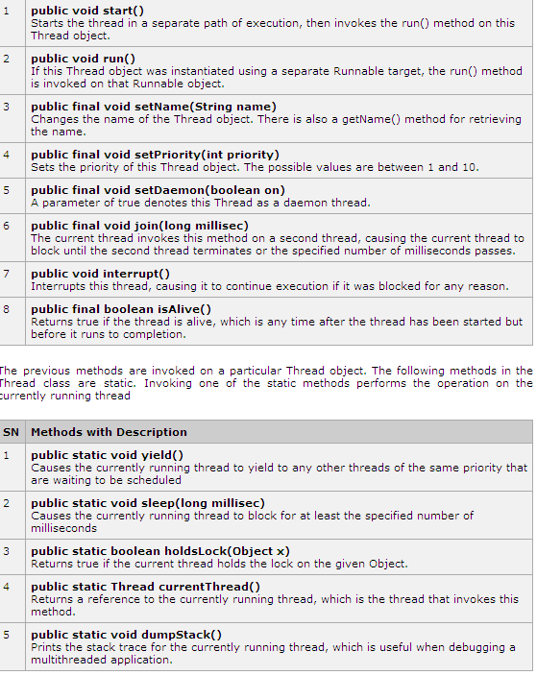

Q) What are three ways in which a thread can enter the waiting state? Or
What are different ways in which a thread can enter the waiting state?
A thread can enter the waiting state by the following ways:
1. Invoking its sleep() method,
2. By blocking on I/O
3. By unsuccessfully attempting to acquire an object's lock
4. By invoking an object's wait() method.
5. It can also enter the waiting state by invoking its (deprecated) suspend() method.
Q) What is the difference between yielding and sleeping?
When a task invokes its yield() method, it returns to the ready state, either from waiting, running or after its creation. When a task invokes its sleep() method, it returns to the waiting state from a running state.
Q) What invokes a thread's run() method?
After a thread is started, via its start() method of the Thread class, the JVM invokes the thread's run() method when the thread is initially executed.
Q) What is the purpose of the wait(), notify(), and notifyAll() methods?
The wait(), notify() and notifyAll() methods are used to provide an efficient way for thread inter-communication.
Q) What are synchronized methods and synchronized statements?
Synchronized methods are methods that are used to control access to an object. A thread only executes a synchronized method after it has acquired the lock for the method's object or class. Synchronized statements are similar to synchronized methods. A synchronized statement can only be executed after a thread has acquired the lock for the object or class referenced in the synchronized statement.
Q) Can Java object be locked down for exclusive use by a given thread? Or What happens when a thread cannot acquire a lock on an object?
Yes. You can lock an object by putting it in a "synchronized" block. The locked object is inaccessible to any thread other than the one that explicitly claimed it. If a thread attempts to execute a synchronized method or synchronized statement and is unable to acquire an object's lock, it enters the waiting state until the lock becomes available.
Q) What’s the difference between the methods sleep() and wait()?
The sleep method is used when the thread has to be put aside for a fixed amount of time. Ex: sleep(1000), puts the thread aside for exactly one second. The wait method is used to put the thread aside for up to the specified time. It could wait for much lesser time if it receives a notify() or notifyAll() call. Ex: wait(1000), causes a wait of up to one second. The method wait() is defined in the Object and the method sleep() is defined in the class Thread.

Q) What is daemon thread and which method is used to create the daemon thread?
Daemon threads are threads with low priority and runs in the back ground doing the garbage collection operation for the java runtime system. The setDaemon() method is used to create a daemon thread. These threads run without the intervention of the user. To determine if a thread is a daemon thread, use the accessor method isDaemon()
When a standalone application is run then as long as any user threads are active the JVM cannot terminate, otherwise the JVM terminates along with any daemon threads which might be active. Thus a daemon thread is at the mercy of the runtime system. Daemon threads exist only to serve user threads.
Q) What do you understand by Synchronization? Or What is synchronization and why is it important? Or Describe synchronization in respect to multithreading? Or What is synchronization?
With respect to multithreading, Synchronization is a process of controlling the access of shared resources by the multiple threads in such a manner that only one thread can access a particular resource at a time. In non synchronized multithreaded application, it is possible for one thread to modify a shared object while another thread is in the process of using or updating the object's value. Synchronization prevents such type of data corruption which may otherwise lead to dirty reads and significant errors.
E.g. synchronizing a function:
public synchronized void Method1 () {
// method code.
}
E.g. synchronizing a block of code inside a function:
public Method2 (){
synchronized (this) {
// synchronized code here.
}
}
Q) When you will synchronize a piece of your code?
When you expect that your shared code will be accessed by different threads and these threads may change a particular data causing data corruption, then they are placed in a synchronized construct or a synchronized method.
Q) Why would you use a synchronized block vs. synchronized method?
Synchronized blocks place locks for shorter periods than synchronized methods.
Q) What is an object's lock and which objects have locks?
Answer: An object's lock is a mechanism that is used by multiple threads to obtain synchronized access to the object. A thread may execute a synchronized method of an object only after it has acquired the object's lock. All objects and classes have locks. A class's lock is acquired on the class's Class object.
Q) Can a lock be acquired on a class?
Yes, a lock can be acquired on a class. This lock is acquired on the class's Class object.

Q) Is there a separate stack for each thread in Java?
Yes. Every thread maintains its own separate stack, called Runtime Stack but they share the same memory. Elements of the stack are the method invocations,
called activation records or stack frame. The activation record contains pertinent information about a method like local variables.
Q) What happens if you try to start a thread thats already been started?
A) Exception in thread "main" java.lang.IllegalThreadStateException

Singleton class
Conditions of Singleton pattern:
1) One and only one instance of that Class.
2) Can't be cloned as cloning creates a new object violating Design principles of SingletonPattern.
3) Any sub-class of Singleton class should not be allowed as there is a default constructor in Sub-class and using that multiple objects can be created. So Singleton class should have private default constructor to avoid getting invoked using super() from sub-class constructor.
4) Make instance variable as Volatile. volatile ensures that multiple threads handle the object correctly when it is being initialized in the SingletonPattern. For more details about "volatile", please see at the end of this article.
5) Also, it should be designed in such a way that even after De-Serialization too, same object should be returned. As making serialization and de-serialization multiple instances can be created. I have given an example for this too.

//Full example (SingletonPattern.java)
public class SingletonPattern {
private volatile static SingletonPattern object=null;
private SingletonPattern(){} //No subclass can be created because of this private default constructor.

public static SingletonPattern getInstance(){ //Never put synchronized in method, else other threads will be
//blocked for getting object.
if(object==null){ //Check instance, if there isn't one, enter a synchronized block.
synchronized (SingletonPattern.class) { //We only synchronized the first time through.
if(object==null){ //Once in the block, double check for null and create an instance.
object=new SingletonPattern();
}
}
}
return object;
}
public Object clone() throws CloneNotSupportedException {
throw new CloneNotSupportedException("Cloning of this class is not allowed");
}
}

//Main test class (SingletonMain.java)
================Tries to extend SingletonClass: Prohibited================
/*public class SingletonMain extends SingletonPattern {
public SingletonMain(){} //Not allowed, as super class constructor is private.
public static void main(String[] args) {
SingletonPattern obj=SingletonPattern.getInstance();
System.out.println(obj);

}
}
*/
/*public class SingletonMain extends SingletonPattern { //Not allowed as it assumes a default constructor
//Constructor code is not written here. //should be there in super class.
public static void main(String[] args) {
SingletonPattern obj=SingletonPattern.getInstance();
System.out.println(obj);

}
}
*/

================Tries to clone SingletonClass: Prohibited================
//Now your class need to implement Cloneable Interface and then only use the below
//code, else it will throw exception. Because if a class doesn't implement Cloneable,
//it can't be cloned.

public class SingletonMain implements Cloneable {
public static void main(String[] args) throws Exception {
SingletonPattern obj=SingletonPattern.getInstance();
System.out.println(obj);
SingletonPattern main=(SingletonPattern)(obj.clone()); //Will throw exception, cloning is prohibited.
System.out.println(main);
}
}

//Output when run SingletonMain class
SingletonPattern@360be0
Exception in thread "main" java.lang.CloneNotSupportedException: Cloning of this class is not allowed
at SingletonPattern.clone(SingletonPattern.java:17)
at SingletonMain.main(SingletonMain.java:25)

============================volatile===========================
Making instance volatile ensures that mulitple threads handle the object correctly when it is being
initialized to the SingletonPattern class.

To Understand example of volatile keyword in java let’s go back to Singleton pattern in Java and see
double checked locking in Singleton with Volatile and without volatile keyword in java.

//This example is representation of Singleton Pattern discussed above

public class SingletonPattern {
private static volatile SingletonPattern _instance;
public static SingletonPattern getInstance() {
if(_instance == null){
synchronized(SingletonPattern.class){
if(_instance == null)
_instance = new SingletonPattern();
}
}
return _instance;
}
}
------------------
If you look at the code carefully you will be able to figure out:
1) We are only creating instance one time
2) We are creating instance lazily at the time of first request comes.

If we do not make _instance variable volatile then Thread which is creating _instance of SingletonPattern is
not able to communicate other thread, that instance has been created until it comes out of the SingletonPattern
block, so if Thread A is creating SingletonPattern instance and just after creation lost the CPU, all other
threads will not be able to see value of "_instance" as not null and they will believe its still null.

Why because reader threads are not doing any locking and until writer thread comes out of synchronized
block, memory will not be synchronized and value of _instance will not be updated in main memory. With
Volatile keyword in Java this is handled by Java himself and such updates will be visible by all reader
threads.

=======Last point to get the same object afer De-Serialization============
Now suppose we want the above Singleton class to be serializable. We can implement the Serializable interface
for the above class and be done with it. But in that case we won’t be able to protect the singleton nature
of the instance, such that after de-serialization there will be more than one instance of the class.
This can be proved as follows:

Writing again the singleton pattern class:
////////////SingletonPattern.java
================================================
import java.io.ObjectStreamException;
import java.io.Serializable;
public class SingletonPattern implements Cloneable, Serializable{
private volatile static SingletonPattern object=null;
private SingletonPattern(){} //No subclass can be created because of this private default constructor.

public static SingletonPattern getInstance(){ //Never put synchronized in method, else other threads will be
//blocked for getting object.
if(object==null){ //Check instance, if there isn't one, enter a synchronized block.
synchronized (SingletonPattern.class) { //We only synchronized the first time through.
if(object==null){ //Once in the block, double check for null and create an instance.
object=new SingletonPattern();
}
}
}
return object;
}
public Object clone() throws CloneNotSupportedException {
throw new CloneNotSupportedException("Cloning of this class is not allowed");
}
}
================================================
//////Main class to fetch SingletonPattern Object and do Serialization:
import java.io.File;
import java.io.FileInputStream;
import java.io.FileOutputStream;
import java.io.ObjectInputStream;
import java.io.ObjectOutputStream;

public class TestMain {
public static void main(String[] args) throws Exception{
SingletonPattern object=SingletonPattern.getInstance();
System.out.println("Original Singleton Object: "+object);

ObjectOutputStream out = new ObjectOutputStream(new FileOutputStream(new File("out3.dat")));
out.writeObject(object);
out.close();

ObjectInputStream in = new ObjectInputStream(new FileInputStream(new File("out3.dat")));
SingletonPattern deserObject = (SingletonPattern) in.readObject();

//After de-serialization we will get different object
System.out.println("Deserialized Singleton Object: "+deserObject);
in.close();

//Returning false, should return true.
System.out.println("This shows false, should be true: "+(object == deserObject));

//Returning true.
System.out.println("This shows true: "+(object == SingletonPattern.getInstance()));
}
}
////Output:
Original Singleton Object: SingletonPattern@164eee
Deserialized Singleton Object: SingletonPattern@16a04a
This shows false, should be true: false
This shows true: true
================================================

You can analyze the output, two different Singleton Objects are there and equality shows FALSE.
This breaks the rule of Singleton class. The way to avoid this is using another hook, the readResolve()
method. The readResolve() method is called when the ObjectInputStream has read an object from the
stream and is preparing to return it to the caller. ObjectInputStream checks whether the class of the
object defines the readResolve() method. If the method is defined, the readResolve method is called to
allow any changes in the object before it is returned.

So now we will add the readResolve() method in SingletonPattern.java, the modified code is:

================================
import java.io.ObjectStreamException;
import java.io.Serializable;
public class SingletonPattern implements Cloneable, Serializable{
private volatile static SingletonPattern object=null;
private SingletonPattern(){} //No subclass can be created because of this private default constructor.

public static SingletonPattern getInstance(){ //Never put synchronized in method, else other threads will be
//blocked for getting object.
if(object==null){ //Check instance, if there isn't one, enter a synchronized block.
synchronized (SingletonPattern.class) { //We only synchronized the first time through.
if(object==null){ //Once in the block, double check for null and create an instance.
object=new SingletonPattern();
}
}
}
return object;
}
public Object clone() throws CloneNotSupportedException {
throw new CloneNotSupportedException("Cloning of this class is not allowed");
}
private Object readResolve() throws ObjectStreamException {
return getInstance();
}
}
================================

Now if you run the TestMain program again you will see output (it will show equality as TRUE) and
objects are equal. It means that even after de-serialization, we still have only one instance of the class in
our JVM.
==============
//Output
Original Singleton Object: SingletonPattern@164efe
Deserialized Singleton Object: SingletonPattern@164efe
This shows false, should be true: true
This shows true: true
==============

--------------------------------END-----------------------------------

Q) How to crack the Singleton class.

A)by using java reflection API and Extralization and searilization

Q) How do you prevent for creating another instance of Singleton using reflection?
Answer: This is similar to previous interview question. Since constructor of Singleton class is supposed to be private it prevents creating instance of Singleton from outside but Reflection can access private fields and methods, which opens a threat of another instance. This can be avoided by throwing Exception from constructor as “Singleton already initialized”
Q) How do you prevent for creating another instance of Singleton during serialization?
Answer: You can prevent this by using readResolve() method, since during serialization readObject() is used to create instance and it return new instance every time but by using readResolve you can replace it with original Singleton instance. I have shared code on how to do it in my post Enum as Singleton in Java. This is also one of the reason I have said that use Enum to create Singleton because serialization of enum is taken care by JVM and it provides guaranted of that.

serialization and externalization
Q) What is the difference between Serializable and Externalizable interface in Java?
This is most frequently asked question in Java serialization interview. Here is my version Externalizable provides us writeExternal() and readExternal() method which gives us flexibility to control java serialization mechanism instead of relying on Java's default serialization. Correct implementation of Externalizable interface can improve performance of application drastically.
Q) How many methods Serializable has? If no method then what is the purpose of Serializable interface?
Serializable interface exists in java.io package and forms core of java serialization mechanism. It doesn't have any method and also called Marker Interface in Java. When your class implements java.io.Serializable interface it becomes Serializable in Java and gives compiler an indication that use Java Serialization mechanism to serialize this object.
Q) While serializing you want some of the members not to serialize? How do you achieve it?
Another frequently asked Serialization interview question. This is sometime also asked as what is the use of transient variable, does transient and static variable gets serialized or not etc. so if you don't want any field to be part of object's state then declare it either static or transient based on your need and it will not be included during Java serialization process.

Q) What are rules of serialization in Java?
Here is a summary of some rules of Java serialization:
An object is serializable only if its class or its superclass implements the Serializable (or Externalizable) interface.An object is serializable (itself implements the Serializable interface) even if its superclass is not. However, the first superclass in the hierarchy of the serializable class, that does not implements Serializable interface, MUST have a no-arg constructor. If this is violated, readObject() will produce a java.io.InvalidClassException in runtime.The no-arg contructor of every non-serializable superclass will run when an object is deserialized. However, the deserialized objects? constructor does not run when it is deserialized. The class must be visible at the point of serialization. All primitive types are serializable. Transient fields (with transient modifier) are NOT serialized, (i.e., not saved or restored). A class that implements Serializable must mark transient fields of classes that do not support serialization (e.g., a file stream). Static fields (with static modifier) are Not serialized. If member vairiables of a serializable object reference to a non-serializable object, the code will compile but a RumtimeException will be thrown.
Q) To serialize an array or a collection all the members of it must be serializable. True /False?
Ans) true.
Q) What is serialization and externalization
A) Serialization is the process of converting an object into a sequence of bits so that it can be persisted on a storage medium (such as a file, or a memory buffer) or transmitted across a network connection link. This process of serializing an object is also called deflating or marshalling an object.
Externalization is same as Sterilization except that WriteObject() and ReadObject() method are called by JVM during sterilization and desterilization of object. One thing you can do with Externalization is that you can store extra information into object like STATIC variables and transient variables or you can add more information if you have any business need. One good example is compressing and uncompressing of data to send it through network or converting one format to other like a BMP image to JPEG or GIF format. Externalization allows you to customize how serialization is done. By implementing externalization you are controlling what gets serialized ( and what doesnot ) as versus default serialization where all non-transient attributes get serialized. For “fat data” classes with a large number of attributes only a few of which needs to persisted, externalization will help you reduce the size of serialized stream and the time taken to serialize the object. But there will be an overhead involved because the runtime has to call your methods to read/write objects.
Performance issue –
1. Further more if you are subclassing your externalizable class you will want to invoke your superclass’s implementation. So this causes overhead while you subclass your externalizable class.
2. methods in externalizable interface are public. So any malicious program can invoke which results into lossing the prior serialized state.

Serialization Super-Class and Constructors
Case 1: Super class doesn’t implement Serializable and provides parameter-less constructor
In this case, the sub class automatically becomes Serializable and it is possible to de-serialize instances of sub class because the super class is providing parameter-less constructor. No problems are detected while performing the serialization or de-serialization operation.
package com.example;
public class SuperSerializable {
public SuperSerializable(){
System.out.println("Inside super constructor");
}
}
************************************************************
package com.example;
import java.io.File;
import java.io.FileInputStream;
import java.io.FileOutputStream;
import java.io.ObjectInputStream;
import java.io.ObjectOutputStream;
import java.io.Serializable;
public class SubSerializable extends SuperSerializable implements Serializable{
public static void main(String[] args) throws Exception{
SubSerializable sub = new SubSerializable();

System.out.println("Serializing");
FileOutputStream fos = new FileOutputStream(new File("c://test"));
ObjectOutputStream oos = new ObjectOutputStream(fos);
oos.writeObject(sub);
System.out.println("De-Serializing");
FileInputStream fis = new FileInputStream(new File("c://test"));
ObjectInputStream ois = new ObjectInputStream(fis);
sub = (SubSerializable)ois.readObject();
}
}
Output:
Inside super constructor
Serializing
De-Serializing
Inside super constructor
Note that during deserialization, the constructor of A is invoked

Case 2: Super class doesn’t implement Serializable and doesn’t provide parameterless constructor
In this case, there are subtle issues because of non-presence of parameter-less constructor. When the serialized object of Sub class is de-serialized then constructor of super class is invoked if the super class doesn’t implement Serializable interface.
package com.example;
public class SuperSerializable {
public SuperSerializable(int a){
System.out.println("Inside super constructor");
}
}
package com.example;
import java.io.File;
import java.io.FileInputStream;
import java.io.FileOutputStream;
import java.io.ObjectInputStream;
import java.io.ObjectOutputStream;
import java.io.Serializable;
public class SubSerializable extends SuperSerializable implements Serializable{
public SubSerializable(){
super(2);
}
public static void main(String[] args) throws Exception{
SubSerializable sub = new SubSerializable();
System.out.println("Serializing");
FileOutputStream fos = new FileOutputStream(new File("c://test"));
ObjectOutputStream oos = new ObjectOutputStream(fos);
oos.writeObject(sub);
System.out.println("De-Serializing");
FileInputStream fis = new FileInputStream(new File("c://test"));
ObjectInputStream ois = new ObjectInputStream(fis);
sub = (SubSerializable)ois.readObject();
}
}
Output:
Inside super constructor
Serializing
De-Serializing
Exception in thread “main” java.io.InvalidClassException: com.example.SubSerializable; com.example.SubSerializable; no valid constructor
at java.io.ObjectStreamClass.checkDeserialize(ObjectStreamClass.java:730)
at java.io.ObjectInputStream.readOrdinaryObject(ObjectInputStream.java:1751)
at java.io.ObjectInputStream.readObject0(ObjectInputStream.java:1347)
at java.io.ObjectInputStream.readObject(ObjectInputStream.java:369)
at com.example.SubSerializable.main(SubSerializable.java:27)
Caused by: java.io.InvalidClassException: com.example.SubSerializable; no valid constructor
at java.io.ObjectStreamClass.(ObjectStreamClass.java:488)
at java.io.ObjectStreamClass.lookup(ObjectStreamClass.java:327)
at java.io.ObjectOutputStream.writeObject0(ObjectOutputStream.java:1130)
at java.io.ObjectOutputStream.writeObject(ObjectOutputStream.java:346)
at com.example.SubSerializable.main(SubSerializable.java:22)
Case 3: Super class implements Serializable and provides parameterless constructor
If the super class implements Serializable interface then it is also serialized when the sub class objects are serialized so the super-class constructor need not be invoked when de-serializing object of sub-class. Here is the code example:
package com.example;
import java.io.Serializable;
public class SuperSerializable implements Serializable{
public SuperSerializable(){
System.out.println("Inside super constructor");
}
}
package com.example;
import java.io.File;
import java.io.FileInputStream;
import java.io.FileOutputStream;
import java.io.ObjectInputStream;
import java.io.ObjectOutputStream;
import java.io.Serializable;

public class SubSerializable extends SuperSerializable implements Serializable{
public static void main(String[] args) throws Exception{
SubSerializable sub = new SubSerializable();
System.out.println("Serializing");
FileOutputStream fos = new FileOutputStream(new File("c://test"));
ObjectOutputStream oos = new ObjectOutputStream(fos);
oos.writeObject(sub);
System.out.println("De-Serializing");
FileInputStream fis = new FileInputStream(new File("c://test"));
ObjectInputStream ois = new ObjectInputStream(fis);
sub = (SubSerializable)ois.readObject();
}
}

Output:
Inside super constructor
Serializing
De-Serializing
It is in line with our expectations. Super class constructor didn't invoke.

Now option two where A implements Serializable and B does not implement Serializable.
-------------------------
public class A implements Serializable{
private String name = null;
public A() {
System.out.println("Inside A's constructor.");
}
public String getName() {
return name;
}
public void setName(String name) {
this.name = name;
}
}
-------------------------
public class B extends A {
private String detail = null;
public B() {
System.out.println("Inside B's constructor.");
}
public String getDetail() {
return detail;
}
public void setDetail(String detail) {
this.detail = detail;
}
}
-------------------------
The output is
01 Inside A's constructor.
02 Inside B's constructor.
03 Begining the serialization process.
04 Serializing Object
05 Serialization complete.
06 Ending the serialization process.
07 Begining the deserialization process.
08 Deserializing Object
09 Name: Test
10 Detail: Test Details
11 Deserialization complete.
12 Ending the deserialization process.

The output remains unchanged. Super class constructor didn't invoke.

Java Serialization rule no 3:
In Object hierarchy the root class needs to implement Serializable interface to ensure serializable
of all attributes within the object hierarchy.
-------------------------

At Last I am discussing how to avoid making a class serializable. Note: If your super class
doesn't implement Serializable, it can't be serialized but if a sub-class implements, then the whole object
hierarchy can be serialized again.

To avoid this we need to re-define "writeObject() and readObject()" methods of ObjectOutputStream and
ObjectInputStream. I am writing re-define because these methods are declared as final, so can't be overridden.

Below is the complete code:
--------------------
//Super class doesn't implement Serializable here but sub class does.
public class SuperClass {
public SuperClass(){
System.out.println("Super class constructor called");
}
}
---------------
//Sub class
import java.io.FileInputStream;
import java.io.FileOutputStream;
import java.io.IOException;
import java.io.ObjectInputStream;
import java.io.ObjectOutputStream;
import java.io.Serializable;

public class BaseClass extends SuperClass implements Serializable {
public String name;
public BaseClass(){
System.out.println("Base class constructor called");
name="Deepak modi";
}
public static void main(String[] args) throws IOException,ClassNotFoundException {
BaseClass b=new BaseClass();
ObjectOutputStream out=new ObjectOutputStream(new FileOutputStream("HoldSerial.txt"));
out.writeObject(b);
System.out.println("Base class object serialized/stored in a file");

ObjectInputStream in=new ObjectInputStream(new FileInputStream("HoldSerial.txt"));
BaseClass bIn=(BaseClass)in.readObject();
System.out.println("Base class object de-serialized/read from file");
System.out.println("Object: "+bIn);
System.out.println("Object name value: "+bIn.name);
}
//Re-defining the method
private void readObject(ObjectInputStream o) throws IOException, ClassNotFoundException {
System.out.println("These objects can't be de-serialized");
throw new IOException("These objects can't be de-serialized");
}
private void writeObject(ObjectOutputStream o) throws IOException {
System.out.println("These objects can't be serialized");
throw new IOException("These objects can't be serialized");
}
public String toString() {
return name;
}
}

//Output when you run this main method:
Super class constructor called
Base class constructor called
These objects can't be serialized
Exception in thread "main" java.io.IOException: These objects can't be serialized
at BaseClass.writeObject(BaseClass.java:33)
at sun.reflect.NativeMethodAccessorImpl.invoke0(Native Method)
at sun.reflect.NativeMethodAccessorImpl.invoke(NativeMethodAccessorImpl.java:39)
at sun.reflect.DelegatingMethodAccessorImpl.invoke(DelegatingMethodAccessorImpl.java:25)
at java.lang.reflect.Method.invoke(Method.java:585)
at java.io.ObjectStreamClass.invokeWriteObject(ObjectStreamClass.java:917)
at java.io.ObjectOutputStream.writeSerialData(ObjectOutputStream.java:1339)
at java.io.ObjectOutputStream.writeOrdinaryObject(ObjectOutputStream.java:1290)
at java.io.ObjectOutputStream.writeObject0(ObjectOutputStream.java:1079)
at java.io.ObjectOutputStream.writeObject(ObjectOutputStream.java:302)
at BaseClass.main(BaseClass.java:17)

//You uncomment the "readObject() and "writeObject()" and then see behavior:
I did that and here is the output:::::::::::

Super class constructor called
Base class constructor called
Base class object serialized/stored in a file
Super class constructor called
Base class object de-serialized/read from file
Object: Deepak modi
Object name value: Deepak modi

Strings

Difference between String and StringBuffer and StringBuilder
String is immutable whereas StringBuffer and StringBuilder can change their values.
String s1 = “name”; here the memory location may be “-921601119”
s1 = s1.concat(“age”); as it is a new object and will be created in another memory location for
ex: - 1647227122
Now for s1 a new object will be created in different memory location , whenever we are applying methods (concat , trim etc ) on the String Object as STRING is IMMUTABLE.
STRINGBUFFER sb1 = “name”;
sb1 = sb1.concat(“age”);
here the same StringBuffer/StringBuider object will not changed and the memory location is same even after applying the methods for ex: 17523401
STRINGBUFFER and STRINGBUILDER objects will modify the same (created) object in the same memory location while we are applying the methods(append,trimToSize etc)
The only difference between StringBuffer and StringBuilder is that StringBuilder is unsynchronized whereas StringBuffer is synchronized.
Criteria to choose among String, StringBuffer and StringBuilder
- If your text is not going to change use a string Class because a String object is immutable.
- If your text can change and will only be accessed from a single thread, use a StringBuilder because StringBuilder is unsynchronized.
- If your text can changes, and will be accessed from multiple threads, use a StringBuffer because StringBuffer is synchronous.
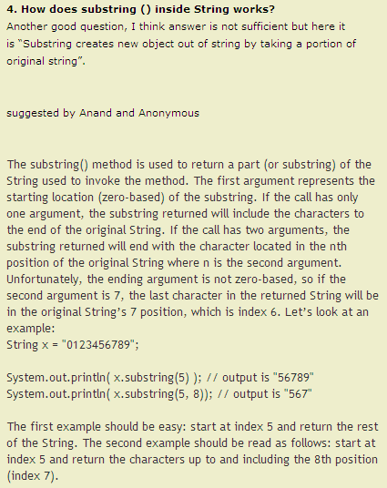
2>> what Intern() method in string.
As shown in the example we have created three Strings in three different ways. Then we have used the "==" operator to determine which Strings are equal. Basically an intern string is the one that has an entry in the global string pool. And if the string is not in global string pool then it will be added. If the pool already contains a string equal to this String object as determined by the equals(Object) method then on invoking the intern method the string from the pool is returned. Otherwise, this String object is added to the pool and a reference to this String object is returned.
It returns a canonical representation for the string object.
The String class maintains a pool of strings privately, which is empty initially.For any two strings s1 and s2, s1.intern() == s2.intern() is true if and only if s1.equals(s2) is true.
Returns a string that has the same contents as this string, but is definetly to be from a pool of unique strings.

String comparison questions
String s1 = new String("A");
String s2 = new String("A");
String s3 = "A";
String s4 = "A";

if(s1.equals(s2)){ //deep comparison (by checking value of class)
System.out.println("Test 1 >> s1.equals(s2) : "+ (s1.equals(s2)));
}
if(s1==s2){//shallow comparison( by checking memory locations)
System.out.println("Test 2 >> s1==s2 : "+ (s1==s2));
}else {
System.out.println("Test 2 >> s1==s2 : "+ (s1==s2));
}
if(s3.equals(s4)){
System.out.println("Test 3 >> s3.equals(s4) : "+ (s3.equals(s4)));
}
if(s3==s4){
System.out.println("Test 4 >> s3==s4 : "+ (s3==s4));
}
if(s1.equals(s3)){
System.out.println("Test 5 >> s1.equals(s3) : "+ (s1.equals(s3)));
}
if(s2==s4){
System.out.println("Test 6 >> s2==s4 : "+ (s2==s4));
}else{
System.out.println("Test 6 >> s2==s4 : "+ (s2==s4));
}
if(s4==s2.intern()){
System.out.println("Test 7 >> s2==s4.intern() : "+ (s4==s2.intern()));
}
OUTPUT:
Test 1 >> s1.equals(s2) : true
Test 2 >> s1==s2 : false
Test 3 >> s3.equals(s4) : true
Test 4 >> s3==s4 : true
Test 5 >> s1.equals(s3) : true
Test 6 >> s2==s4 : false
Test 7 >> s2==s4.intern() : true
String reverse
String s = "ABCDE";
StringBuffer sb = new StringBuffer();
for (int i = s.length()-1; i >= 0; i--) {

sb.append(s.charAt(i));
}
String word reverse program
public String reverseWord(String name){
StringTokenizer strTok = new StringTokenizer(name);
Stack<String> stack = new Stack<String>();
while(strTok.hasMoreTokens()) {
stack.push(strTok.nextToken());
}
StringBuffer revStr = new StringBuffer();
while(!stack.empty()) {
revStr.append(stack.pop());
revStr.append(" ");
}
return revStr.toString();
}
String reverse with Recursive way
public class StringRevRecursion {
public String reverse(String s){
if(s.length()==0)
return s;
return reverse(s.substring(1)) + s.charAt(0);
}

public static void main(String[] args) {
System.out.println(new StringRevRecursion().reverse("1234"));
}
}
Q) Dynamic sorting for Object code

GroupLinksBeanWS [] sorte = new GroupLinksBeanWS[groupLinksByType.length];
sorte = groupLinksByType;
int in, out;
for(out=1; out<groupLinksByType.length; out++){
GroupLinksBeanWS temp = sorte[out];
in = out;
while(in>0 && sorte[in-1].getType().getDescription().compareTo(temp.getType().getDescription())>0){
sorte[in] = sorte[in-1];
--in;
}
sorte[in] = temp;

}
groupLinksByType = sorte;

4>>I have String [] a and string b[] arrays and I want merge them and load into List how can you do it

A>> public class Test {
public static void main(String[] args) {
String[] array1 = {"a", "b", "c"};
String[] array2 = new String[3] ;
//arraycopy(Object src, int srcPos, Object dest, int destPos, int length)
System.arraycopy(array1,0,array2,0,3);
//convert an array to a list
List<String> list = java.util.Arrays.asList(array2);
System.out.println(list);//prints [a, b]

String[] array3 = {"a", "b", "c"};
String[] array4 = {"d", "e", "f"};

List<String> lis = Arrays.asList(array3);
List<String> lis2 = Arrays.asList(array4);
List<String> lis3 = new ArrayList<String>();
lis3.addAll(lis);
lis3.addAll(lis2);

System.out.println(lis3);

}
}
7>>> I have array[100] records one more array with 100 records, but 80 of first array records are repeating in second and second array have 20 extra one and I want then in a set with union all unique 100 records.

A>>> String[] array3 = {"a", "b", "c"};
String[] array4 = {"d", "a", "b"};

List<String> lis = Arrays.asList(array3);
List<String> lis2 = Arrays.asList(array4);
Set<String> lis3 = new HashSet<String>();

lis3.addAll(lis);
lis3.addAll(lis2);

System.out.println(lis3);

Write a program to print fibonacci series.
In mathematics, the Fibonacci numbers or Fibonacci series or Fibonacci sequence are the numbers in the following integer sequence: 0, 1, 1, 2, 3, 5, 8, 13, 21, 34, 55, 89, 144... By definition, the first two numbers in the Fibonacci sequence are 0 and 1, and each subsequent number is the sum of the previous two. Below example shows how to create fibonacci series.
public class MyFibonacci {
public static void main(String a[]){
int febCount = 15;
int[] feb = new int[febCount];
feb[0] = 0;
feb[1] = 1;
for(int i=2; i < febCount; i++){
feb[i] = feb[i-1] + feb[i-2];
}
for(int i=0; i< febCount; i++){
System.out.print(feb[i] + " ");
}
}
}
Output:
0 1 1 2 3 5 8 13 21 34 55 89 144 233 377

How to swap two numbers without using temporary variable?
public class MySwapingTwoNumbers {
public static void main(String a[]){
int x = 10;
int y = 20;
x = x+y;
y=x-y;
x=x-y;
}
}

Sorting

Java Bubble Sort Example
- /*
- Java Bubble Sort Example
- This Java bubble sort example shows how to sort an array of int using bubble
- sort algorithm. Bubble sort is the simplest sorting algorithm.
- */

- public class BubbleSort {

- public static void main(String[] args) {

- //create an int array we want to sort using bubble sort algorithm
- int intArray[] = new int[]{5,90,35,45,150,3};

- //print array before sorting using bubble sort algorithm
- System.out.println("Array Before Bubble Sort");
- for(int i=0; i < intArray.length; i++){
- System.out.print(intArray[i] + " ");
- }

- //sort an array using bubble sort algorithm
- bubbleSort(intArray);

- System.out.println("");

- //print array after sorting using bubble sort algorithm
- System.out.println("Array After Bubble Sort");
- for(int i=0; i < intArray.length; i++){
- System.out.print(intArray[i] + " ");
- }

- }

- private static void bubbleSort(int[] intArray) {

- /*
- * In bubble sort, we basically traverse the array from first
- * to array_length - 1 position and compare the element with the next one.
- * Element is swapped with the next element if the next element is greater.
- *
- * Bubble sort steps are as follows.
- *
- * 1. Compare array[0] & array[1]
- * 2. If array[0] > array [1] swap it.
- * 3. Compare array[1] & array[2]
- * 4. If array[1] > array[2] swap it.
- * ...
- * 5. Compare array[n-1] & array[n]
- * 6. if [n-1] > array[n] then swap it.
- *
- * After this step we will have largest element at the last index.
- *
- * Repeat the same steps for array[1] to array[n-1]
- *
- */

- int n = intArray.length;
- int temp = 0;

- for(int i=0; i < n; i++){
- for(int j=1; j < (n-i); j++){

- if(intArray[j-1] > intArray[j]){
- //swap the elements!
- temp = intArray[j-1];
- intArray[j-1] = intArray[j];
- intArray[j] = temp;
- }

- }
- }

- }
- }

- /*
- Output of the Bubble Sort Example would be

- Array Before Bubble Sort
- 5 90 35 45 150 3
- Array After Bubble Sort
- 3 5 35 45 90 150

- */

2. Mergesort in Java
The Mergesort algorithm can be used to sort a collection of objects. Mergesort is so called divide and conquer algorithm. Divide and conquer algorithms divide the original data into smaller sets of data to solve the problem.

1.2. Mergesort
During the Mergesort process the object in the collection are divided into two collections. To split a collection, Mergesort will take the middle of the collection and split the collection into its left and its right part.
The resulting collections are again recursively sorted via the Mergesort algorithm.
Once the sorting process of the two collections is finished, the result of the two collections is combined. To combine both collections Mergesort start at each collection at the beginning. It pick the object which is smaller and inserts this object into the new collection. For this collection it now selects the next elements and selects the smaller element from both collection.
Once all elements from both collections have been inserted in the new collection, Mergesort has successfully sorted the collection.
To avoid the creation of too many collections, typically one new collection is created and the left and right side are treaded as different collections.

package de.vogella.algorithms.sort.mergesort;

public class Mergesort {
private int[] numbers;
private int[] helper;

private int number;

public void sort(int[] values) {
this.numbers = values;
number = values.length;
this.helper = new int[number];
mergesort(0, number - 1);
}

private void mergesort(int low, int high) {
// Check if low is smaller then high, if not then the array is sorted
if (low < high) {
// Get the index of the element which is in the middle
int middle = low + (high - low) / 2;
// Sort the left side of the array
mergesort(low, middle);
// Sort the right side of the array
mergesort(middle + 1, high);
// Combine them both
merge(low, middle, high);
}
}

private void merge(int low, int middle, int high) {

// Copy both parts into the helper array
for (int i = low; i <= high; i++) {
helper[i] = numbers[i];
}

int i = low;
int j = middle + 1;
int k = low;
// Copy the smallest values from either the left or the right side back
// to the original array
while (i <= middle && j <= high) {
if (helper[i] <= helper[j]) {
numbers[k] = helper[i];
i++;
} else {
numbers[k] = helper[j];
j++;
}
k++;
}
// Copy the rest of the left side of the array into the target array
while (i <= middle) {
numbers[k] = helper[i];
k++;
i++;
}

}
}

Binary Search

3.1. Overview
Binary search requires that the collection is already sorted. For example by Quicksort or Mergesort. Binary search checks the element in the middle of the collection. If the search element smaller or greater then the found element then a sub-array is defined which is then search again. If the searched element is smaller then the found element then the sub-array is from the start of the array until the found element. If the searched element is larger then the found element then the sub-array is from the found element until the end of the array. Once the searched element is found or the collection is empty then the search is over.

3.2. Implementation
Create the Java project "de.vogella.algorithms.search.binary" and a package with the same name.
Create the following program.
package de.vogella.algorithms.search.binary;

public class BinarySearch {
public static boolean contains(int[] a, int b) {
if (a.length == 0) {
return false;
}
int low = 0;
int high = a.length-1;

while(low <= high) {
int middle = (low+high) /2;
if (b> a[middle]){
low = middle +1;
} else if (b< a[middle]){
high = middle -1;
} else { // The element has been found
return true;
}
}
return false;
}
}

Heap Sort in Java

public class HeapSort
{
private static int[] a;
private static int n;
private static int left;
private static int right;
private static int largest;

public static void buildheap(int []a){
n=a.length-1;
for(int i=n/2;i>=0;i--){
maxheap(a,i);
}
}

public static void maxheap(int[] a, int i){
left=2*i;
right=2*i+1;
if(left <= n && a[left] > a[i]){
largest=left;
}
else{
largest=i;
}

if(right <= n && a[right] > a[largest]){
largest=right;
}
if(largest!=i){
exchange(i,largest);
maxheap(a, largest);
}
}

public static void exchange(int i, int j){
int t=a[i];
a[i]=a[j];
a[j]=t;
}

public static void sort(int []a0){
a=a0;
buildheap(a);

for(int i=n;i>0;i--){
exchange(0, i);
n=n-1;
maxheap(a, 0);
}
}

public static void main(String[] args) {
int []a1={4,1,3,2,16,9,10,14,8,7};
sort(a1);
for(int i=0;i<a1.length;i++){
System.out.print(a1[i] + " ");
}
}
}

OUTPUT :

1 2 3 4 7 8 9 10 14 16

JDBC Overview

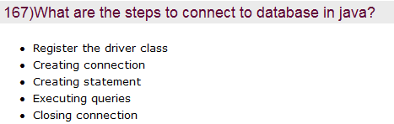
JDBC was first introduced as part of JDK 1.1. JDBC api has its own version and latest version being JDBC 4.1 part of Java SE 7. JDBC 4.1 is a maintenance release of JSR 221.
Using JDBC in our application can be segregated into three major steps as below,
- Obtaining a database connection.
- Execute queries against the connected database and receive results.
- Process the received results.
//step 1 - getting connection
Connection connection = DriverManager.getConnection(
"jdbc:jdbcDriver:database",
databaseUsername, dbpassword);

//step 2 - query execution and getting result
Statement statement = connection.createStatement();
ResultSet resultSet = statement.executeQuery("SELECT * FROM employee");

//step 3 - parsing the result from ResultSet
while (resultSet.next()) {
int empid = rs.getInt("empid");
String empname = rs.getString("empname");
}
Above is a general and basic illustration of using JDBC.

Database Connection
Getting a database connection consists of two substeps loading driver and creating connection.

Types of JDBC Drivers
There are four types of JDBC drivers,
- Type 1 (Bridge) – JDBC-ODBC Bridge – calls native code of locally available ODBC driver.
- Type 2 (Native) – Native-API / Partly Java Driver – calls vendor’s native driver on client side and this code calls database over network.
- Type 3 (Middleware) – All Java / Net-Protocol Driver – pure-java driver that calls the server-side middleware.
- Type 4 (Pure), All Java / Native-Protocol Driver – pure-java driver that uses database native protocol.

Loading Driver
In JDBC 4.0 this step is not required and all the all divers found in classpath are loaded automatically. When we want to load a java class into JVM we use Class.forName and the same is followed here. We choose a type of JDBC driver and use Class.forName to load it.
try {
Class.forName("sun.jdbc.odbc.JdbcOdbcDriver");
}
catch(Exception e){
System.out.println("Exception is loading the driver."+e);
}

Getting a Connection
There are two classes that allows to connect to a database DriverManager and DataSource. DriverManager is most popular and easier to use.
Key object is Connection which allows to interact with database and execute queries. DriverManager has a method named getConnection and we use this to get an instance of Connection.
For getConnection we need to pass username, password of database and a connection url. JDBC Connection URL varies based on the database used. Following are for some of the popular databases,
- MySQL JDBC Connection URL: jdbc:mysql://hostname:3306/ – 3306 is mysql default port
- Java DB Connection URL: jdbc:derby:testdb;create=true
- Microsoft SQL Server JDBC Connection URL – jdbc:microsoft:sqlserver://localhost:1433;DatabaseName=northwind
- Oracle JDBC connection URL – jdbc:oracle:thin:@hostname:1521:MyDatabase
- PostgresSQL JDBC Connection URL – jdbc:postgresql:template1
- DB2 JDBC Connection URL – jdbc:db2:test
- Derby JDBC Connection URL – jdbc:derby:/test;create=true
- H2 Connection URL: jdbc:h2:tcp://localhost:9092/test
try{
Connection connection = DriverManager.getConnection(connectionUrl,dbUserName,dbPassword");
}
catch( SQLException sqlEx ){
System.out.println( "Exception in getting a connection"+sqlEx);
}

SQL Execution and Getting Results
Using the Connection obtained we execute SQL statements. Before executing the SQL we need to compose the statements. There are three difference ways for creating a sql statement and they are by using Statement or PreparedStatement or CallableStatement.
Statement:
This is used for creating a static sql statement. Why do we call this as static? Everytime we use this Statement object the sql query is compiled, irrespective of it is used earlier or not. Generally this Statement is used in simple scenarios and when we are sure a same query will never be executed again.
PreparedStatement:
We can use PreparedStatement to create a pre-compiled SQL statement. It gives better performance compared to Statement as it is precompiled and this is applicable when the same sql will be executed multiple times.
PreparedStatement pstmt = connection.prepareStatement("UPDATE
EMPLOYEE SET name = ? WHERE empid = ?");
pstmt.setString(1, "Joe");
pstmt.setInt(2, 10829);

CallableStatement:
This is different from the above two statement. This is specially used for executing stored procedures.
Once the statement is creating using any one of the above three statements then we call their respective execute methods and get the result back from database.

Parsing Results
ResultSet is the object returned when a select query is performed. ResultSet represents multiple records of data. We can read records from a ResultSet using a cursor. Cursor is pointer to a record. By default, after we read a record the pointer moves to the next record then we can read the following records. TYPE_FORWARD_ONLY, TYPE_SCROLL_INSENSITIVE and TYPE_SCROLL_SENSITIVE are three types using which the cursor is controlled. This section calls for a detailed separate article :)
I am going to write a series of articles on JDBC and will cover the following JDBC Driver Types, PreparedStatement, CallableStatement, ResultSet, Cursors, Transactions, Stored Procedures, Metadata. Please add a comment to let me know if you want me to write on any other thing specific in JDBC.

JDBC Basic Example
package com.javapapers.jdbc;

import java.sql.Connection;
import java.sql.DriverManager;
import java.sql.ResultSet;
import java.sql.SQLException;
import java.sql.Statement;

public class JDBCBasicExample {
private Connection connection = null;
private Statement statement = null;
private ResultSet resultSet = null;

public static void main() throws Exception {

try {

// using mysql driver - download and add in classpath
Class.forName("com.mysql.jdbc.Driver");

connection = DriverManager.getConnection("jdbc:mysql://localhost/employeedb?"
+ "user=dbusername&password=dbpassword");
statement = connection.createStatement();
resultSet = statement.executeQuery("select * from employee");

while (resultSet.next()) {
String employeename = resultSet.getString("name");
int empid = resultSet.getString("empid");
Date dateofBirth = resultSet.getDate("dateofbirth");
System.out.println("Employee Name: " + employeename);
System.out.println("Employee ID: " + empid);
System.out.println("Employee Date of Birth: " + dateofBirth);
}

} catch(SqlException sqe) {
sqe.printStacktrace();
}
finally {
try {
resultSet.close();
statement.close();
connection.close();
}catch(Exception e){}
}
}
}
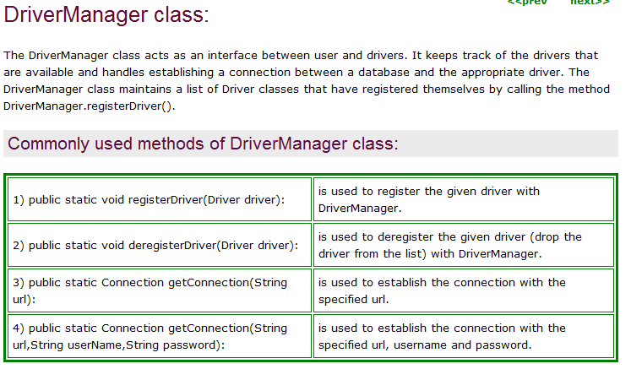
3>> what is the metadata how it is used in JDBC
A>> import java.sql.*;
public class JdbcMetaDataGettables {
static public final String driver = "com.mysql.jdbc.Driver";
static public final String connection =
"jdbc:mysql://localhost:3306/komal";
static public final String user = "root";
static public final String password = "root";
public static void main(String args[]) {
try {
Class.forName(driver);
Connection con =
DriverManager.getConnection(connection, user, password);
Statement st = con.createStatement();
String sql = "select * from person";
ResultSet rs = st.executeQuery(sql);
ResultSetMetaData metaData = rs.getMetaData();
int rowCount = metaData.getColumnCount();
System.out.println("Table Name : " + metaData.getTableName(2));
System.out.println("Field \tsize\tDataType");
for (int i = 0; i < rowCount; i++) {
System.out.print(metaData.getColumnName(i + 1) + " \t");
System.out.print(metaData.getColumnDisplaySize(i + 1) + "\t");
System.out.println(metaData.getColumnTypeName(i + 1));
}
} catch (Exception e) {
System.out.println(e);
}
}
}

Output
Table Name : person
Field size DataType
id 2 VARCHAR
cname 50 VARCHAR
dob 10 DATE

